SENSOR ADJUSTMENT
Sensor distance adjustment
The #time2time distance sensor is a digital optoreflectance sensor, with a red light emitter and receiver. The sensor emits a light that is reflected by the object in front of it and detects the reflected light to determine the distance to the object.
To adjust the sensor there are two potentiometers on the side of the sensor. They can be seen in the left image.
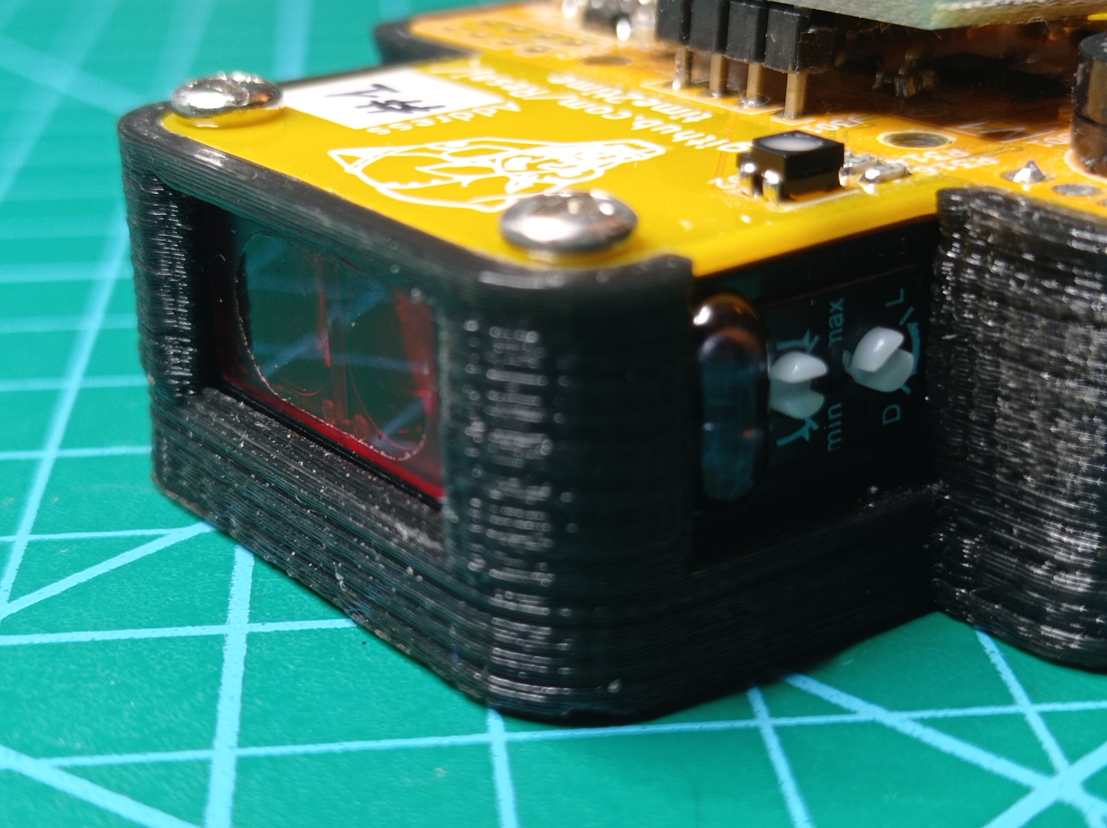
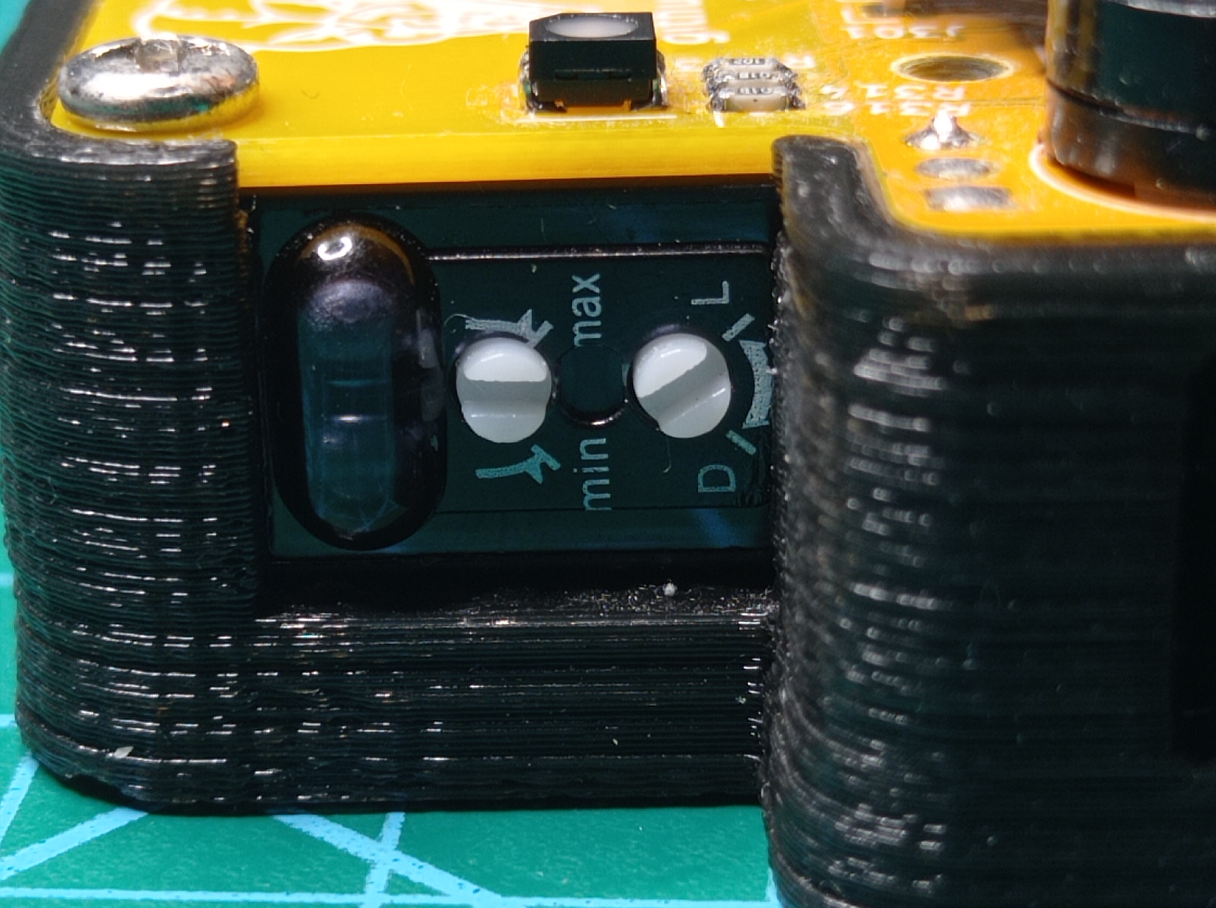
- Potentiometer with the inscription “min” and “max”: it is used to adjust the detection distance threshold, which can be up to 2 meters.
- Potentiometer with the inscription “D” and “L”: it is used to determine the polarity of the sensor output depending on the detection. It can be 0 or 1.
Sensor reflection problems with white floor and sensor height adjustment
One of the most important details to take into account when adjusting the sensor is that the light emitter has a certain aperture. Because of this reason, if the detection threshold is too high, the sensor may detect the floor. Therefore, it is advisable to vary the height of #time2time to separate it from the floor the higher the detection threshold.
It may happen that if the floor is very dark, it will never reflect the light no matter how large the specified distance threshold is.
But it can also happen that the floor is very light and is detected by the sensor with a short threshold.

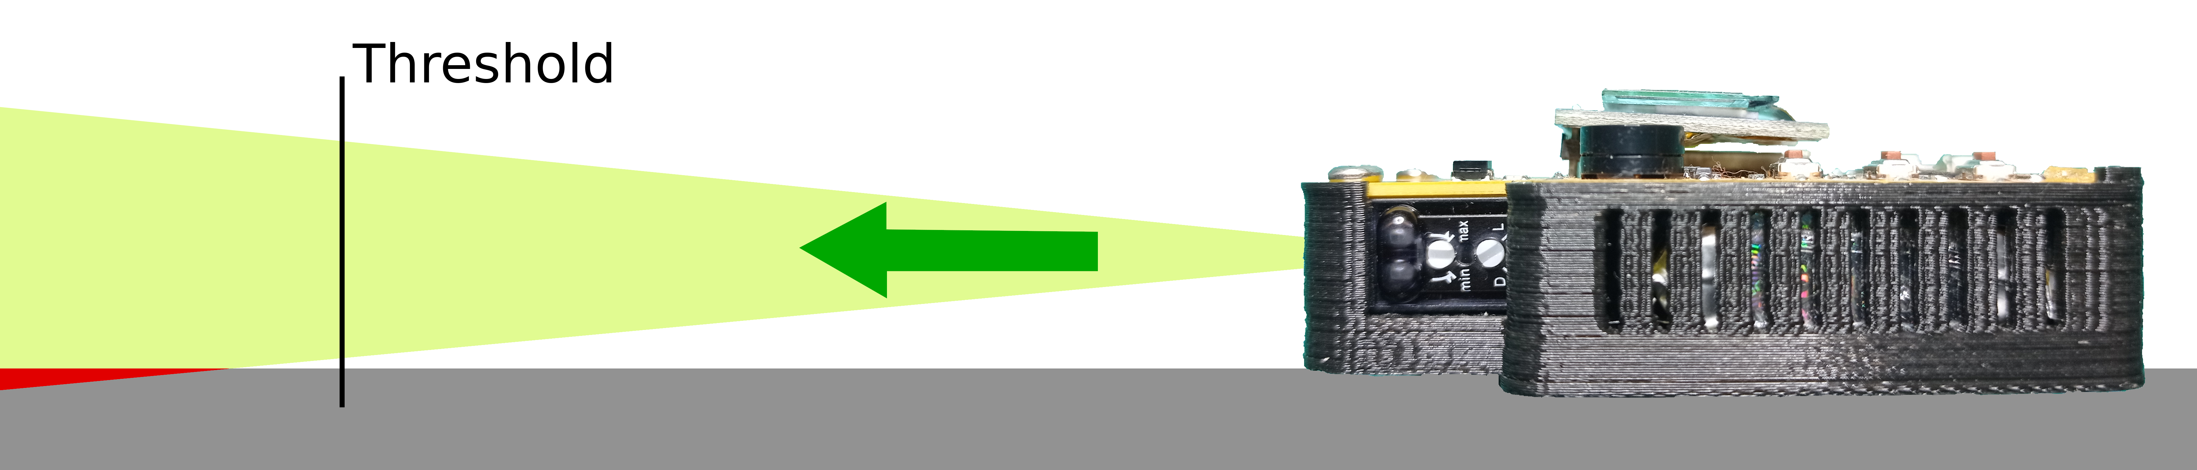

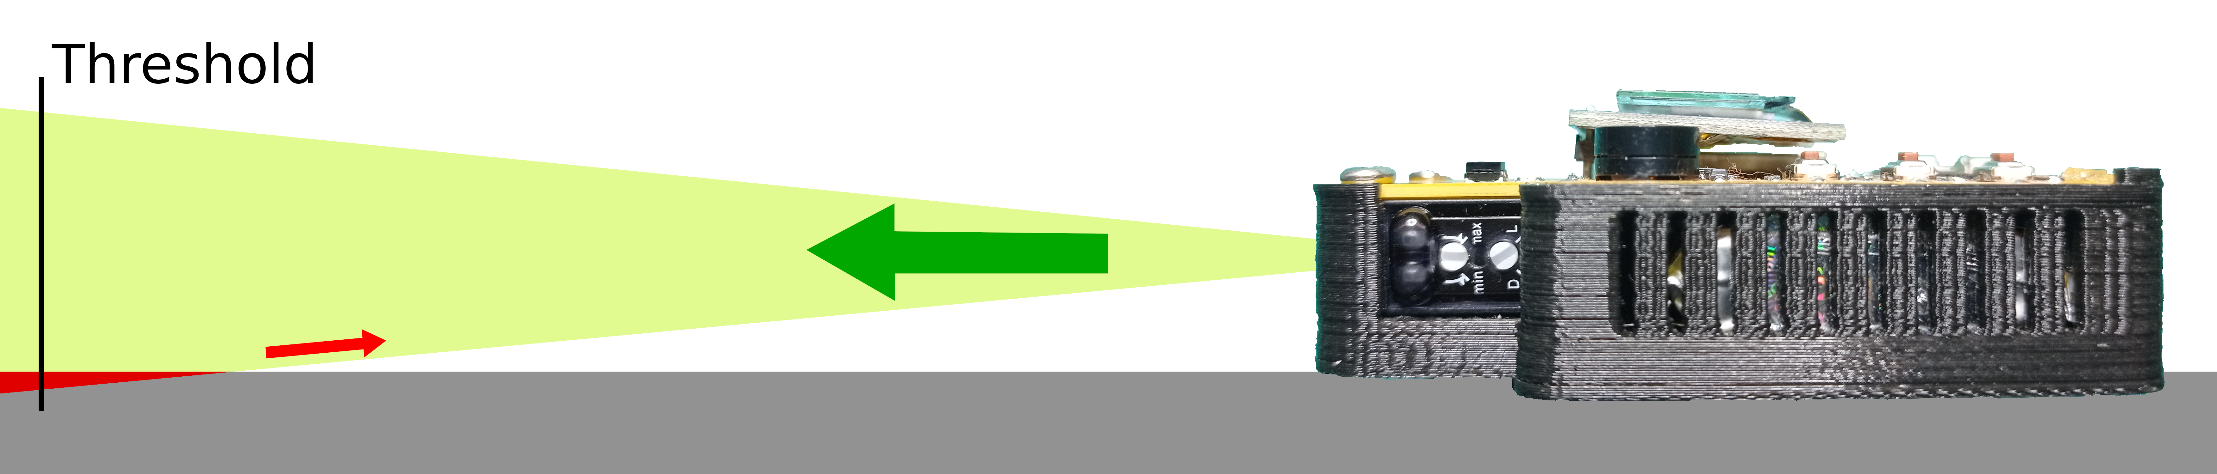

Problems detecting dark objects or glass
As it is a light sensor, dark or transparent colors can decrease the light reflection, so it is advisable to do previous test to adjust the sensor detection range and the #time2time height. This is specially important when a robot competition is to be held and each robot is built differently. So it is advisable to test them one by one or to standardize the robots construction rules so that they can be detected thanks to certain light parts or reflectors that can reflect the light back to the sensor.

